|  |  |  |  |
| --- | --- | --- | --- |
| **Input** | **Expected Output** | **Actual Output** | **Pass?** |
| Student ID: 12345  Student Name: Andrew Rohn  Student Major: Computer Science  <INSERT>  Student ID: 12345  <FIND> | “Student information was successfully added to database.”  Student ID: 12345  Name: Andrew Rohn  Major: Computer Science  GPA: 4.0 | “Student information was successfully added to database.”  Student ID: 12345  Name: Andrew Rohn  Major: Computer Science  GPA: 4.0 | Yes |
| Student ID: -50687  Student Name: Andrew Rohn  Student Major: Computer Science  <INSERT>  Student ID: 50687  Student Name: Andrew Rohn  Student Major: Computer Science  <INSERT>  Student ID: 50687  <UPDATE>  Choose Grade: B  Choose Credits: 3  Student ID: 50687  <FIND> | “Please enter a valid numeric student ID. Ex: 12345”  “Student information was successfully added to database.”  “Student information was successfully updated.”  Student ID: 50687  Name: Andrew Rohn  Major: Computer Science  GPA: 3.0 | “Please enter a valid numeric student ID. Ex: 12345”  “Student information was successfully added to database.”  “Student information was successfully updated.”  Student ID: 50687  Name: Andrew Rohn  Major: Computer Science  GPA: 3.0 | Yes |
| Student ID: 68734  Student Name: Jacob Ray  Student Major: Art  <INSERT>  Student ID: 68734  Student Name: Heather Jones  Student Major: Math  <INSERT>  Student ID: 68734  <FIND>  Student ID: 68734  <DELETE>  Student ID: 68734  <FIND> | “Student information was successfully added to database.”  “Student ID already exists. Please enter another Student ID.”  Student ID: 68734  Name: Jacob Ray  Major: Art  GPA: 4.0  “Student information was successfully removed from database.”  “Student ID doesn’t exist. Please enter another Student ID.” | “Student information was successfully added to database.”  “Student ID already exists. Please enter another Student ID.”  Student ID: 68734  Name: Jacob Ray  Major: Art  GPA: 4.0  “Student information was successfully removed from database.”  “Student ID doesn’t exist. Please enter another Student ID.” | Yes |
| Student ID: 50248  Student Name: Donald Trump  Student Major: Political Science  <INSERT>  Student ID: 50247  <UPDATE>  Student ID: 50247  <FIND>  Student ID: 50247  <DELETE>  Student ID: 50248  <FIND> | “Student information was successfully added to database.”  “Student ID doesn’t exist. Please enter another Student ID.”  “Student ID doesn’t exist. Please enter another Student ID.”  “Student ID doesn’t exist. Please enter another Student ID.”  Student ID: 50248  Name: Donald Trump  Major: Political Science  GPA: 4.0 | “Student information was successfully added to database.”  “Student ID doesn’t exist. Please enter another Student ID.”  “Student ID doesn’t exist. Please enter another Student ID.”  “Student ID doesn’t exist. Please enter another Student ID.”  Student ID: 50248  Name: Donald Trump  Major: Political Science  GPA: 4.0 | Yes |
| Student ID: 39156  Student Name: Hector Sanchez  Student Major: Electrical Engineering  <INSERT>  Student ID: 39156  <UPDATE>  Choose Grade: A  Choose Credits: 6  Student ID: 39156  <UPDATE>  Choose Grade: B  Choose Credits: 3  Student ID: 39156  <FIND> | “Student information was successfully added to database.”  “Student information was successfully updated.”  “Student information was successfully updated.”  Student ID: 39156  Name: Hector Sanchez  Major: Electrical Engineering  GPA: 3.67 | “Student information was successfully added to database.”  “Student information was successfully updated.”  “Student information was successfully updated.”  Student ID: 39156  Name: Hector Sanchez  Major: Electrical Engineering  GPA: 3.67 | Yes |

Screen Capture of me successfully compiling and executing my Java program:

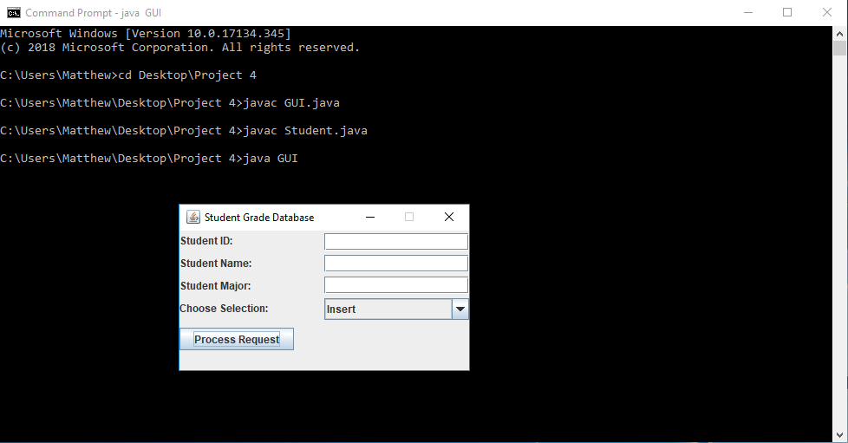

**Screen Captures of Test Case #1:**

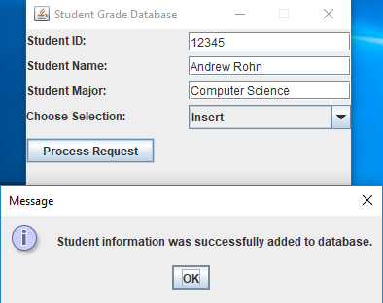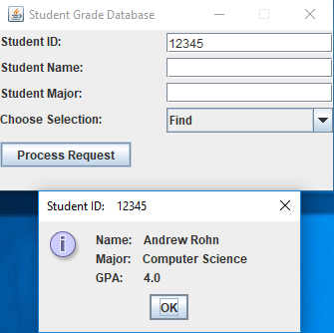

**Screen Captures of Test Case #2:**

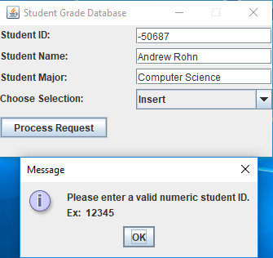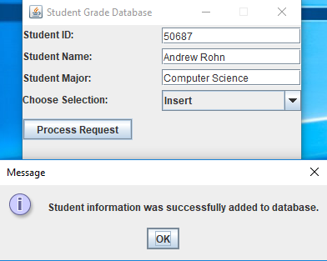

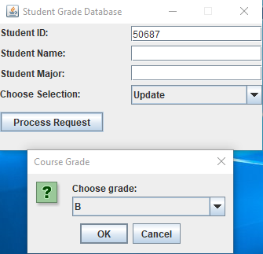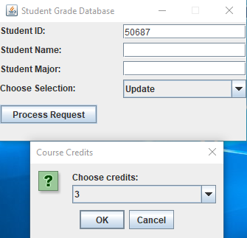

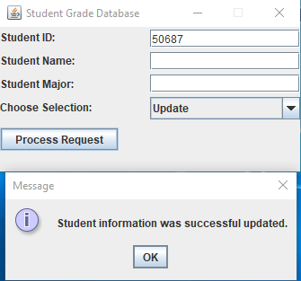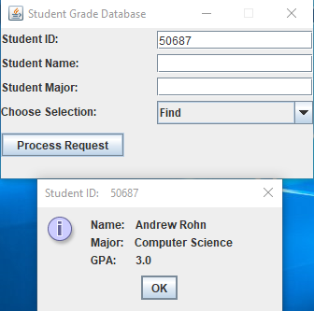

**Screen Captures of Test Case #3:**

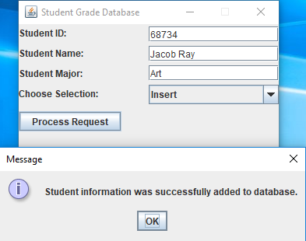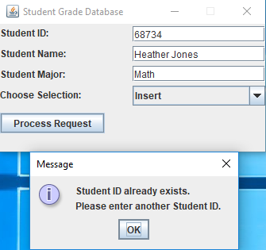

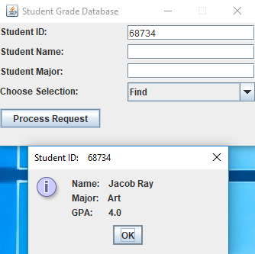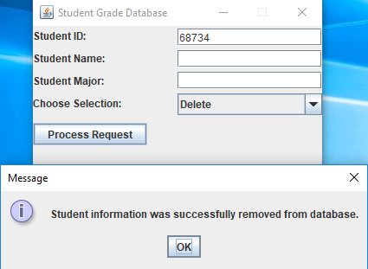

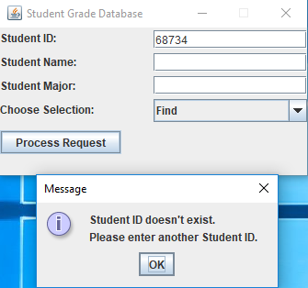

**Screen Captures of Test Case #4:**

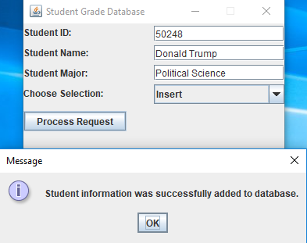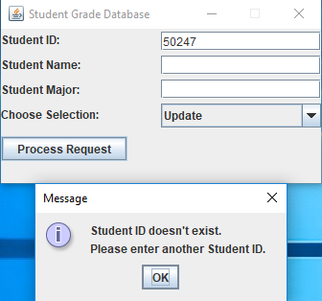

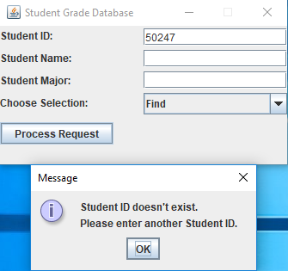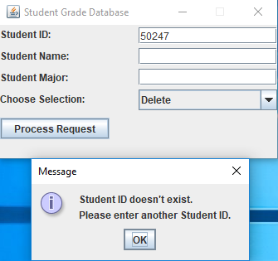

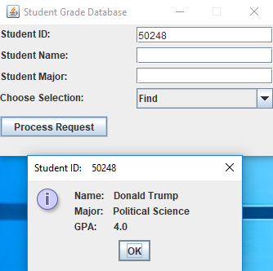

**Screen Captures of Test Case #5:**

